Matthew Howa

Computer Graphics

HW1

In this assignment I wrote computeVector that took two faces (each with 3 point) and computed a vector from the 3 points. Next I finished computeNormals which grabs 3 faces, computes 2 vectors from the faces, then takes the cross product in order to compute the nomals. Finally we iterate through the normalize (between 0-1).

The second part required me to update updateModelViewMatrix in order to make the teapot rotate. Using a rotational matrix around the y axis I was able to correctly make the model spin.

g_modelViewMatrix[0] = cos(angle);

g_modelViewMatrix[2] = -sin(angle);

g_modelViewMatrix[5] = 1.0f;

g_modelViewMatrix[10] = cos(angle);

g_modelViewMatrix[8] = sin(angle);

Where angle is being set by getTime();

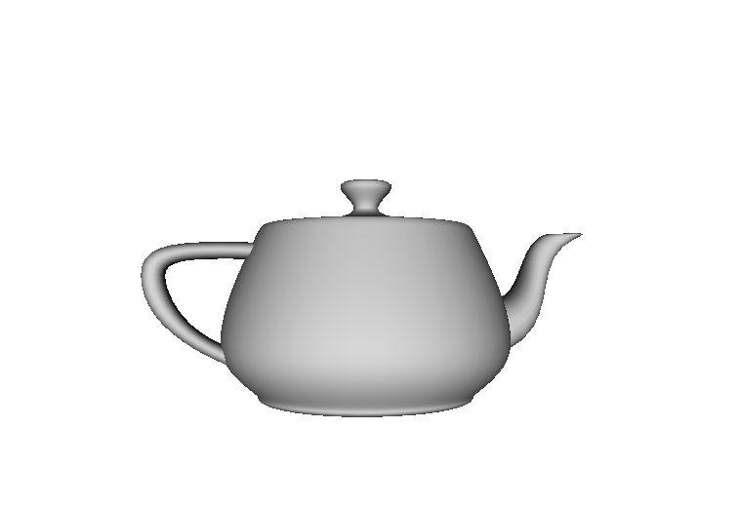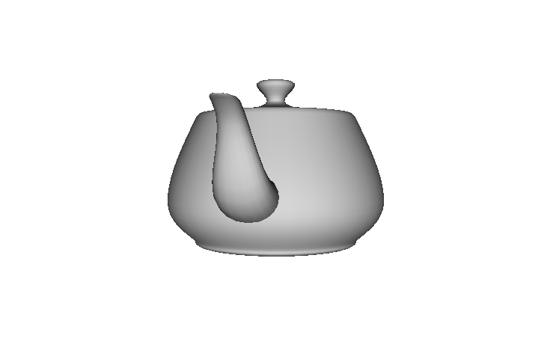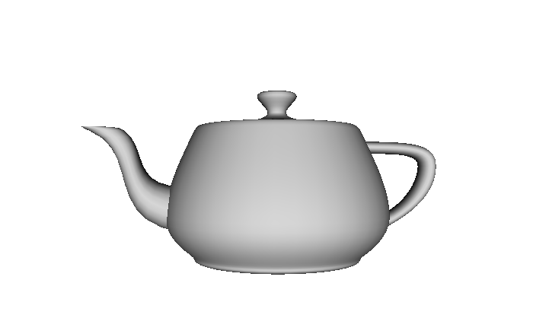

Link to Video: <https://youtu.be/3yd05dFocXs>